Thursday 21st January
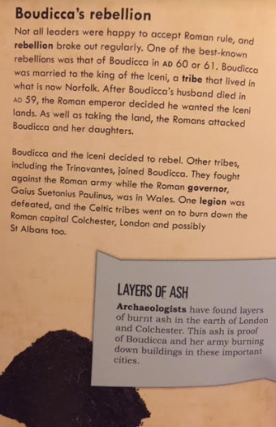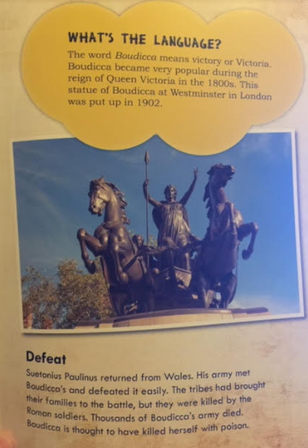

Read the text above and answer the questions

Boudicca’s rebellion
- How long did Boudicca’s rebellion last?
- What is the name of Boudicca’s tribe?
- Name 2 things which the Romans did to Boudicca.
- In the text box ‘Layer of Ash’. What does the ash prove?
Page 11
- What does the word Boudicca mean?
- Why did the Victorian’s put up a statue of Boudicca?
- Who defeated Boudicca’s army?
- What had the tribes done?
- What happened to Boudicca?

