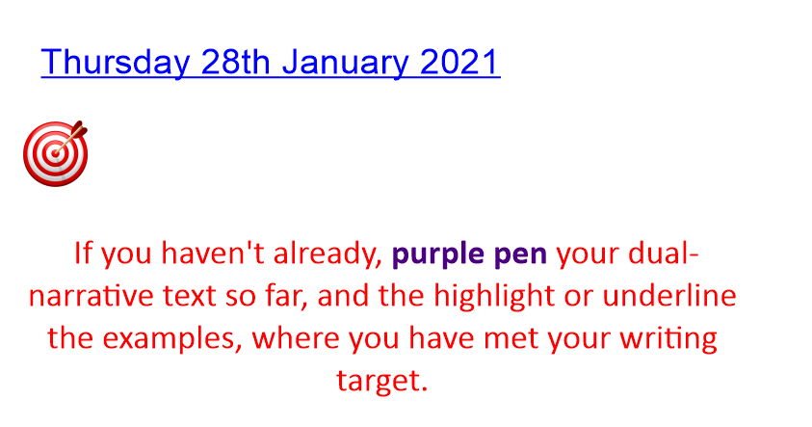
Look back at your plan from yesterday.
Create a word bank for your ending.
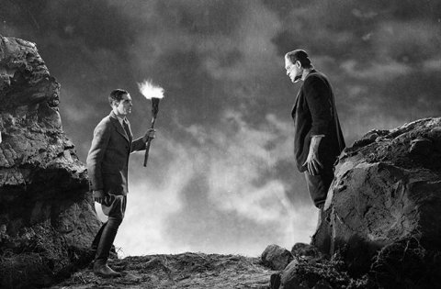

Verbs | Adverbs | Adjectives | Nouns

Now, we are going to look to write the final part of our innovated dual-narrative:

1. Explain how you felt after hearing the story
2. Describe what happens to Victor Frankenstein
3. Describe what you see
4. Explain how you feel at the end

Look back at your WAGOLL of Frankenstein to support your writing.

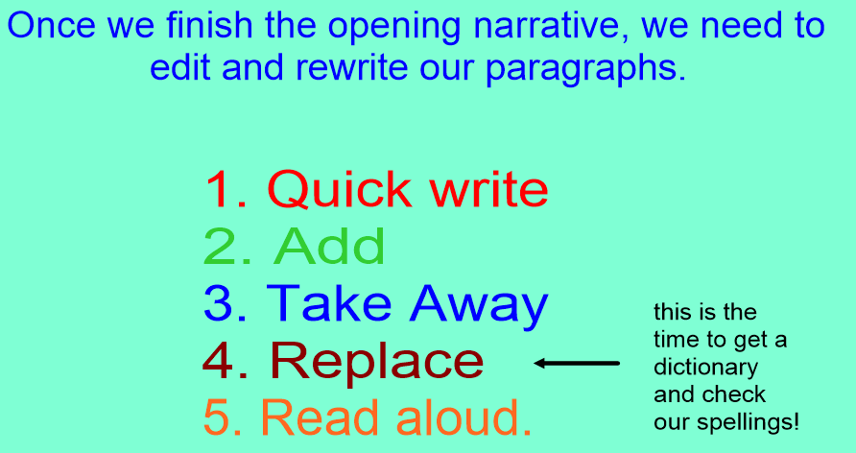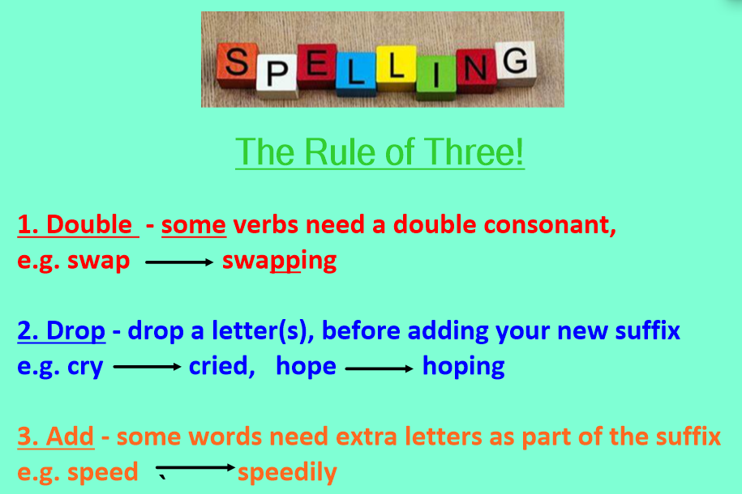
If you have time, use the grammar grid to prove that you have met the criteria!

LI: to be able to identify grammar features within a text
I will be successful if:
- I can explain what the grammar is
- I can find examples of the feature within the text

Grammar Grid
Year 6 Writing Expectation | My Example | Teacher
Co-ordinating Conjunction Sentence

Subordinate Conjunction Sentence

Fronted Adverbial

Expanded Noun Phrase

Prepositional Phrase

Modal Verb

Speech

Adverb for time / detail

Punctuation for parenthesis

Relative Clause

Semi colon

Colon

Dash

Passive verbs

My target (more than once).

Friday 29th January 2021
