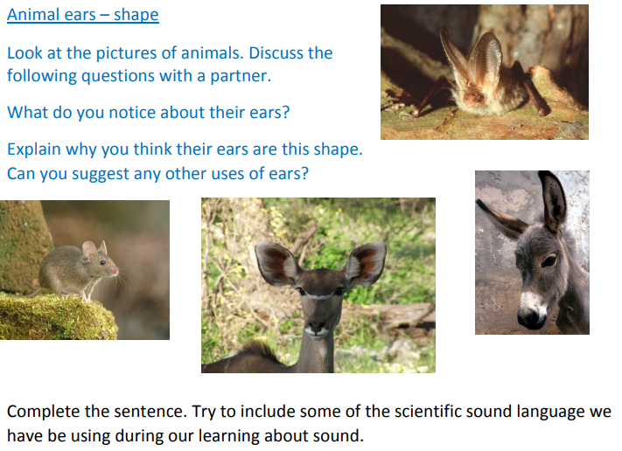
Science – Sounds – 28th January 2021

I have noticed that animals’ ears are
_________________________________________________________________________________

_________________________________________________________________________________

I think this is so they
__________________________________________________________________________________

__________________________________________________________________________________

__________________________________________________________________________________

