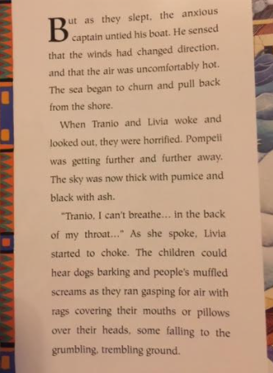
Read the text above and answer the questions.
- Why did the captain untie his boat? Use the word because in your answer.
_____________________________________________________________________________________________________________________________________________________________________________________________________________________________________________________________________
- How do you think Tranio and Livia are feeling as the boat moves away from Pompeii? Use the word because in your answer.
_____________________________________________________________________________________________________________________________________________________________________________________________________________________________________________________________________
- Why were the people in Pompeii cover their mouths with rags or pillows? Use the word because in your answer.
_____________________________________________________________________________________________________________________________________________________________________________________________________________________________________________________________________
- Why is the sky thick with ash and pumice? Use the word because in your answer.
_____________________________________________________________________________________________________________________________________________________________________________________________________________________________________________________________________

