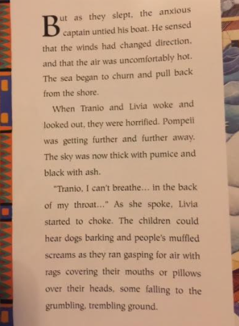
Read the text above and complete the grid.
Emotions grid: how do Tranio and Livia feel? Select an emotion and then explain why they feel that way.
One has been done for you as an example.
Emotion | Explanation
Anxious | They are anxious because they don’t know what will happen
Scared

