Thursday 21st January / Li: to be able to write an opening of a Rags to Riches story (tricky)
I will be successful if:
- I can use full stops and capital letters
- I can use coordinating conjunctions (and, so, but)
- I can use subordinating conjunctions (because, while, when)
- I can use expanded noun phrases (2 adjectives before the noun)
- I can use verb
- I can use adverbs
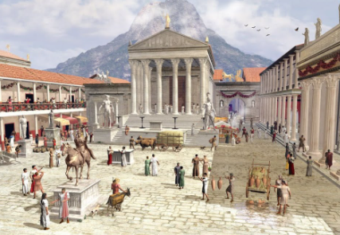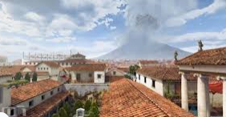
Write the opening paragraph of our story ‘The Hero of Pompeii’
Action Points to include:
- Describe the city of Pompeii
- Describe Mount Vesuvius
- Introduce Lucas
__________________________________________________________________________________________________________________________________________________________________________________________________________________________________________________________________________________________________________________________________________________________________________________________________________________________________________________________________________________________________________________________________________________________________________________________________________________________________________________________________________________________________________________________________________________________________________________________________________________________________________________________________________________________________________________________________________________________________________________________________________________________________________________________________________________________________________________________________________________________________________________________________________________

