L.I:- To be able to recognise the size of the angles in triangles.
I will be successful if..
- I know that there are 180 degrees inside a triangle.
- I can describe and name the properties of triangles.
- I can identify the missing angles.
- I can subtract mentally.
Try it!
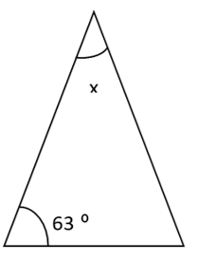
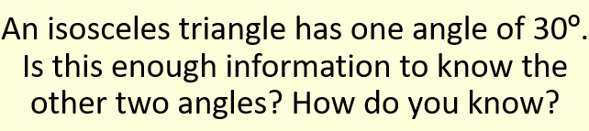

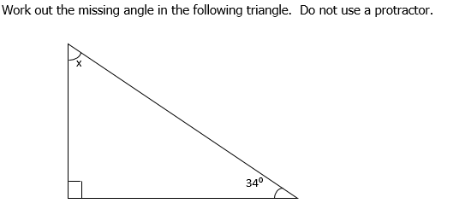

Apply it!
