**L.I:- To be able to find the equivalent fraction, decimal and percentage**

**and use this to solve problems.**

I will be successful if..

* I can convert fractions, decimals and percentages.
* I can multiply and divide.
* I can add and subtract amounts.
* I can annotate and eliminate answers.

**Can you find the percentages of these amounts?**

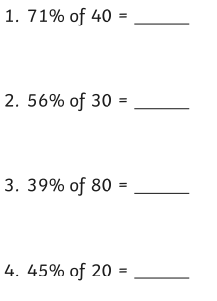

**Match the decimal to the fraction and percentage.**

**What is the strategy you should use?**

