27.1.2021- Maths
LI: To be able to identify a third
I am able to understand that a third is splitting a whole into 3
I am able to write a third as a fraction.
Tick the shapes which show a third. Explain why these shapes show a third, in your book. Use vocabualry such as equal and unequal parts.
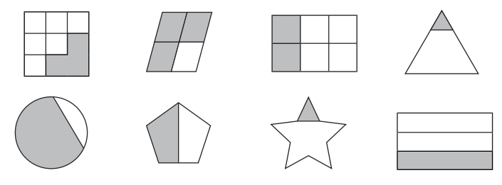

How do you write a third as a fraction?

