LI: To retrieve information from the text.
I can find key information in the text.
I can skim, scan and trap information,
I can explain my answers, using the evidence in the text.

Using the WAGOLL, label the image below with the features, which are accurate to the description.
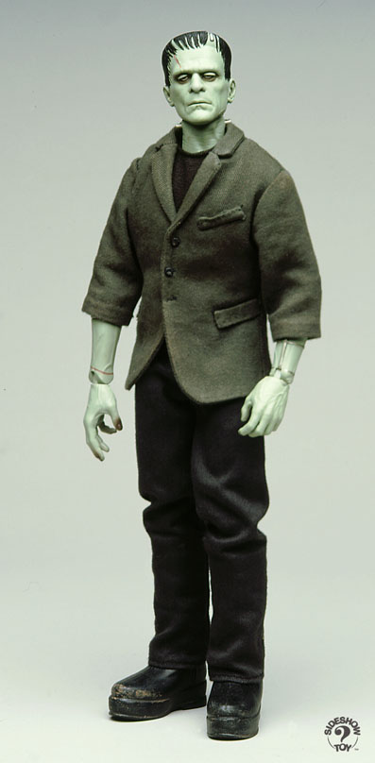
Every part of him fitted his great size. I’d chosen his features in the hope they’d be beautiful. Beautiful!? His muscles and veins were barely covered by his yellow skin. His hair was shiny black and flowing. His teeth were pearly white.
But all was only the more horrible against his watery yellow eyes, his shrivelled skin, his straight black lips. An Egyptian mummy brought to life wouldn’t be as hideous as that Thing. I’d gazed on him when he was unfinished, and he was ugly then. But when those muscles and joints were able to move, he became… a Thing of Nightmares.
Now, identify and explain which of the Creature’s features are incorrect (or not shown) in the image.
Feature | Evidence the image is wrong

Find and copy the adverb that tells us Captain Walton wrote his account straight away.
____________________________________________________________________

Read paragraph 3. Find and copy the phrase, which suggests it was early morning.
___________________________________________________________

Visualisation
Read the extract below. Then, draw the character Doctor Frankenstein.
Label the specific features, using the evidence from the text.
The man (nearly frozen to death) was skeleton-thin from exhaustion and suffering. Once safely on-board, this man, who had madness barely contained within his blood-shot eyes, told me his horrifying story.

True or False?
Prove the statement is true or false, by copying the key information from the text.
 | True | False | Evidence
All the matter Frankenstein used was collected from the graveyard.

It was winter, when the Creature was brought to life.

Frankenstein and the Creature both headed off on their travels.

‘Captain Walton was disgusted by Dr Frankenstein’s story and behaviour’.
Do you agree with this statement?

Tick one.

Yes
No
Maybe
Explain your choice fully, using evidence from the text.
____________________________________________________________________________________
____________________________________________________________________________________
____________________________________________________________________________________
____________________________________________________________________________________
____________________________________________________________________________________
____________________________________________________________________________________
_____________________________________________________________________________________
Quick Write! Write a descriptive paragraph about this scene.
Verbs | Adverbs | Adjectives | Nouns
