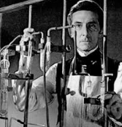
Dr. Frankenstein was driven by selfish desires.
Agree | Disagree

