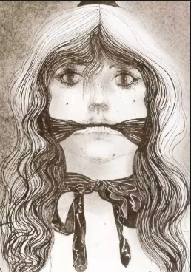
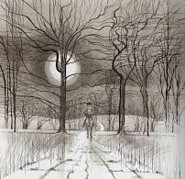
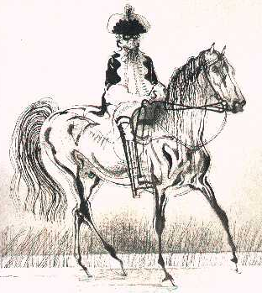
Date:
LI: to be able to recall the events of a Narrative Poem
I will be successful:
- I can recall key events
- I can order them correctly
- I can identify key action points and details
It was a dark and sinister night and the Highway Man approached the inn. | Bess, the landlord’s daughter was waiting for him. | The servant heard them talking.
Soldiers tied Bess up and used her as a trap for The Highway Man. | Bess, sacrificed herself to save The Highway Man | The Highway Man was mad with grief and came back but was killed by the soldiers.

Date:
LI: to be able to recall the events of a Narrative Poem
I will be successful:
- I can recall key events
- I can order them correctly
- I can identify key action points and details

