Tuesday 26th January
Instructions
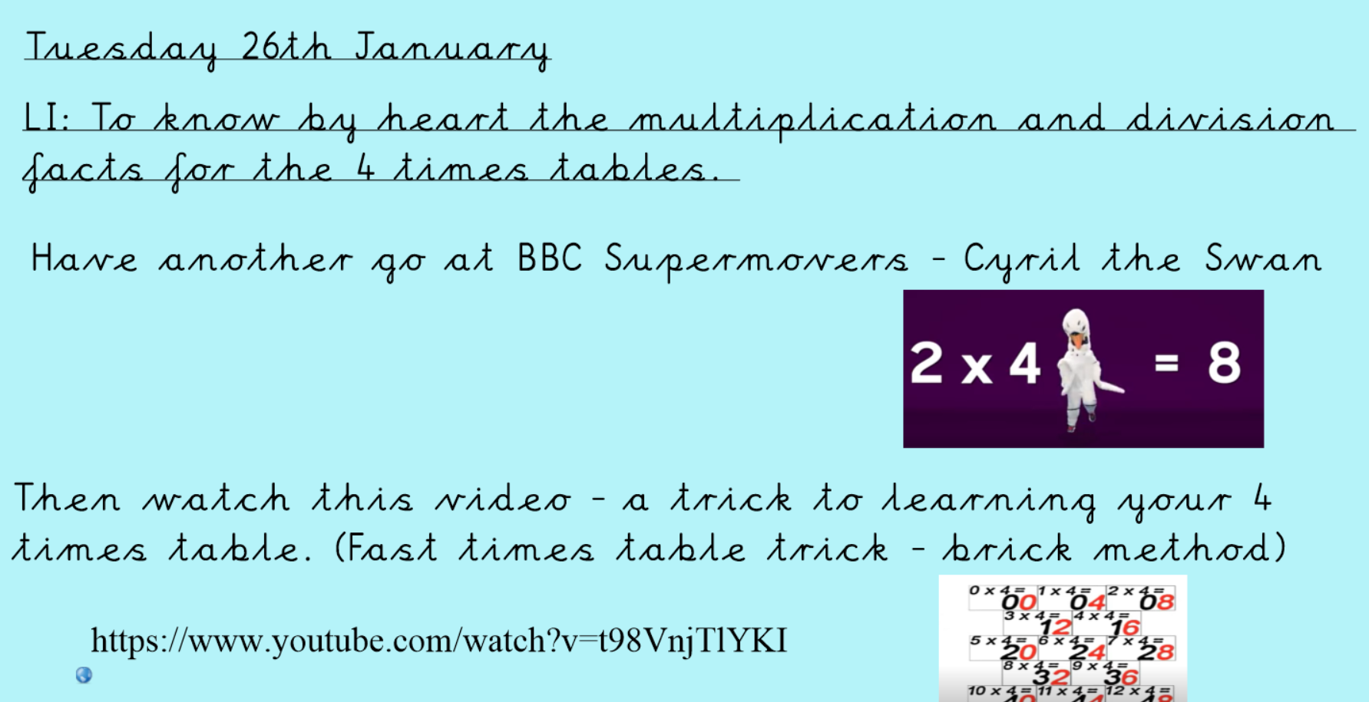
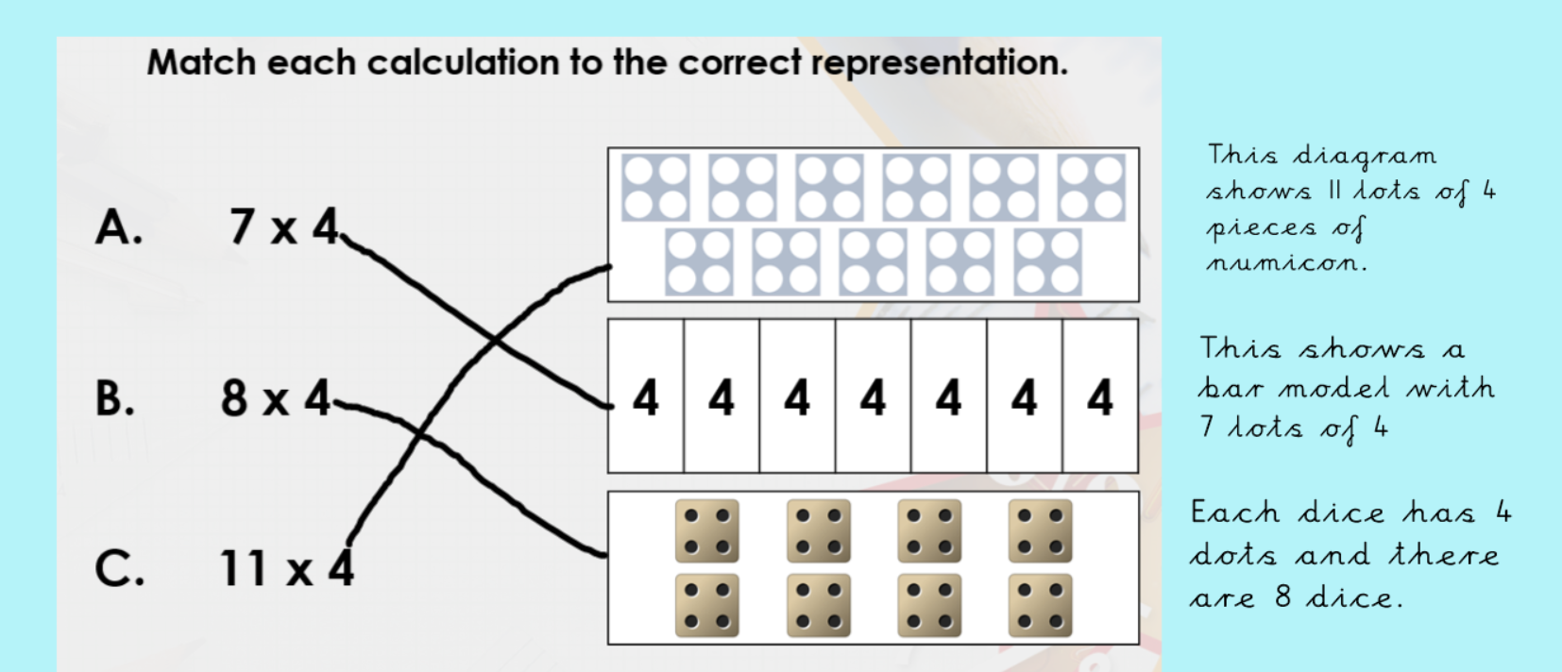
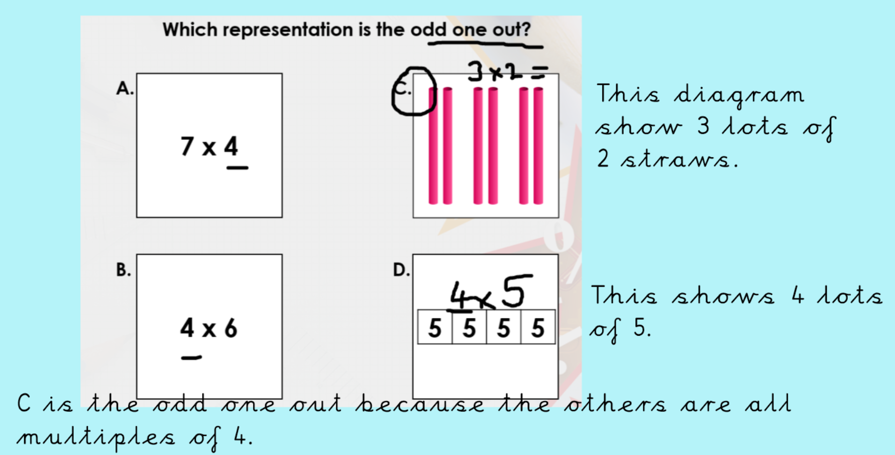
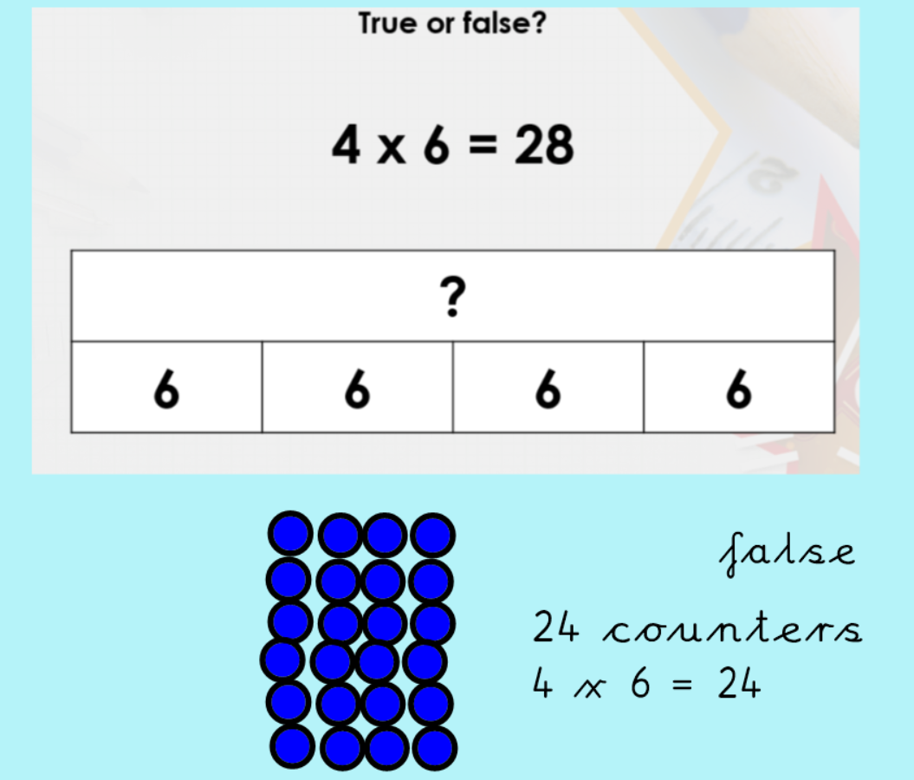
Now have a go at the 4 times table activity sheet.
You can also make one of the 4 times table chatterboxes and use it to help you learn your times tables.

