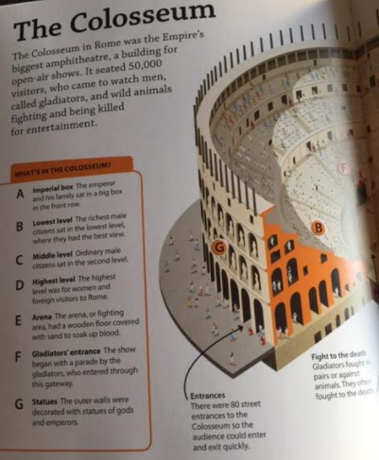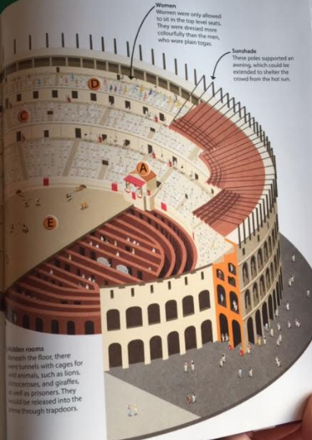
Tuesday 26th January
The Colosseum
Match the information to the correct heading.
Imperial box
Lowest level
Middle level
Highest level
Arena
Gladiators’ entrance
Statues
Ordinary male citizen’s sat in the second level.
The show began with a parade by the gladiators, who entered through this gateway
The outer walls were decorated with statues of gods and emperors
The emperor and his family sat in a big box in the front row.
The highest level was for women and foreign visitors to Rome.
The arena, or fighting area, had a wooden floor covered in sand to soak up blood.
The richest male citizens sat in the lowest level, where the best seats were.

Complete the table with the information from the text
Entrance
These poles supported an awning, which could be extended to shelter the crowd from the hot sun.
Women
Fight to the death
Beneath the floor, there were tunnels with cages for wild animals, such as lions, rhinoceroses, and giraffes, as well as prisoners. They would be released into the arena through trapdoors.

Answer these questions
How do we know that the Colosseum is big? Find and copy a phrase. _____________________________________________
Why did people go to the Colosseum? ___________________________________________________________________

