Tuesday 2nd February
LI: to be able to identify and use coordinating conjunctions
I will be successful if:
- I can recall coordinating conjunctions
- I can identify coordinating conjunctions in a sentence
- I can use coordinating conjunctions

FANBOYS- What do the letters stand for?
F=______________
A=______________
N=______________
B=______________
O=______________
Y=______________
S=_______________

Identify the coordinating conjunction in each sentence.
It was hot and humid in Pompeii.
Lucas wanted to escape but he was scared.
The captain told Lucas he could fish or mend the boat.
Vesuvius erupted so Lucas climbed onto his boat.
It was a bright sunny day in Pompeii yet Lucas was still sad.

Choose the best coordinating conjunction to complete the sentence (and, but, so, yet, or)
Lucas worked really hard on the boat ___________ he would be given a good meal.
The clouds blocked out the sun _________ everything went dark.
Rain _______ shine Lucas was out in his boat.
The sun shone ___________ Lucas still shivered.
Pompeii was destroyed __________ Lucas still remembered it.
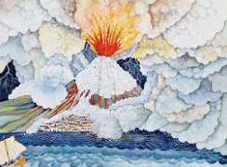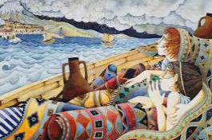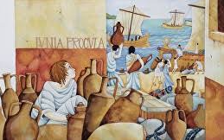
Sentence Creator- write your own sentences using – and, so, but, or.
_______________________________________________________________________________________________________________________________________________________________________________________________________________________________________________________________________________________________________________________________________________________________________________________________________________________________________________________________________________________________________________________________________________________________________________________________________________________________________________________________________________________________________________________________________________________________________________________________________________________________________________________________________________________________________________________________________________________________________________________________________________________________________________________________________________________________________________________________________________________________________________________________________________________________________________________________________________________________________________________________________________________________________________________________________________________________________________________________________________________________________________________________________________________________________________________________________________________________________________________________________________________________________________________________________________________________________________

