Look back at your plan from yesterday.
Create a word bank for your setting – you can use one of the images to help you with this.
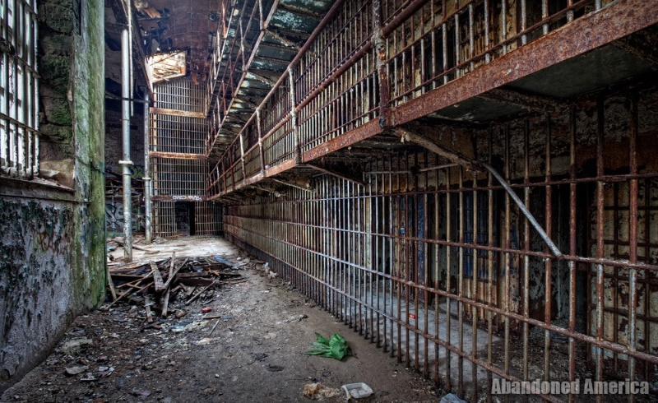
Verbs | Adverbs | Adjectives | Nouns

Now, we are going to look to write the first part of our innovated dual-narrative:

Action Points:

- Describe where you are.
- Explain why you are there
- Describe what you see first- how does it make you feel?
- Explain who you discover- where were they? What do they look like?
- Describe what you do with the person you discover.

Look back at your WAGOLL of Frankenstein to support your writing.

