Li: to be able to predict a story using clues
I will be successful if:
- I can describe the clues
- I can infer meaning from the clues
- I can use the clues to create a sensible prediction
Look at the images and predict what our new story will be about. Think about where it is and what is happening. Write your predictions in the boxes. Please write in full sentences and explain your predictions clearly. E.g. I think ______________ because____________.
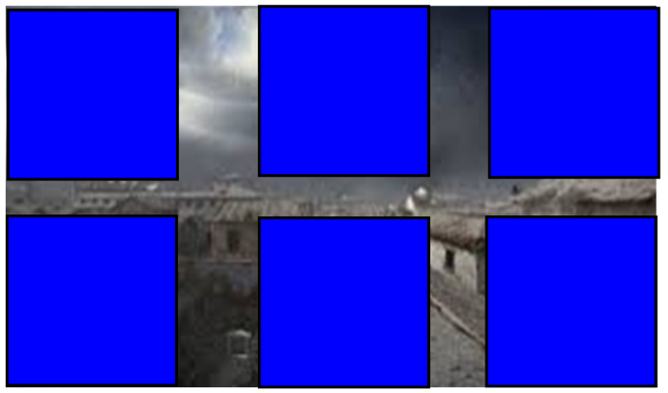
Image 1 Prediction:
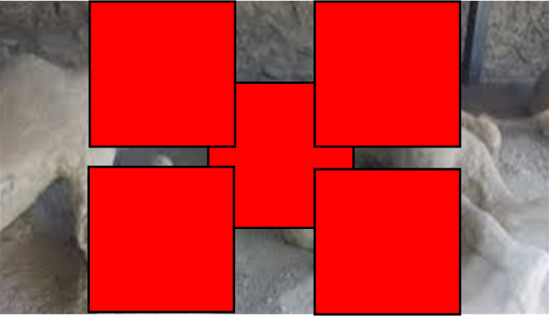
Image 2 Prediction:
Image 3 Prediction:

