Tuesday 19th January
Timeline of Roman Britain
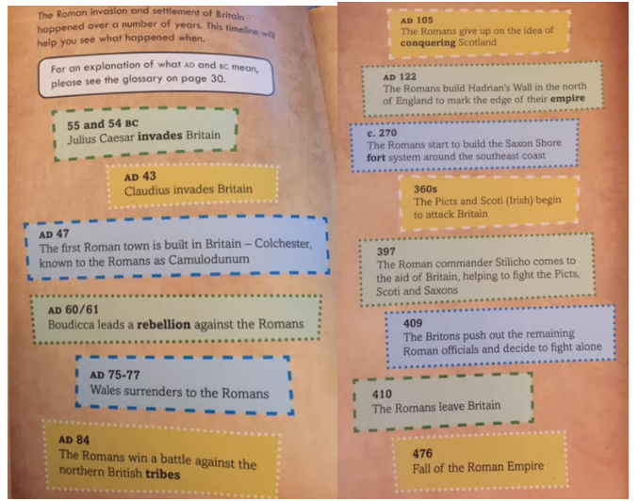
Read the text and complete the diagram above.
Fill in the blanks using the information given.
