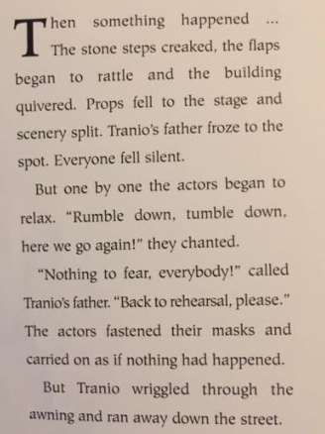
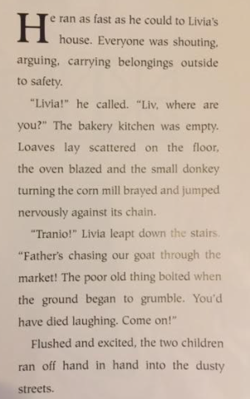

Answer the questions about the text we have just read.
- Find and copy three things which happened when the tremors started.
______________________________________________
______________________________________________
______________________________________________
- They chanted.
Which word is closest in meaning to chanted?
Tick one.
Whisper quietly
Shout loudly
Scream noisily
Sing repeatedly

- How do we know that Dion wasn’t worried about the tremors? Find and copy a phrase from the text.
___________________________________________________
- Where did Tranio go after he left the theatre?
___________________________________________________
- Describe what the bakery was like when Tranio arrived.
______________________________________________________________________________________________________________________________________________________________________________
- Why did the goat run away?
____________________________________________________
- Why do Tranio and Livia go outside?
____________________________________________________

