Tuesday
Skill Check: Retrieve and Record information (2b)
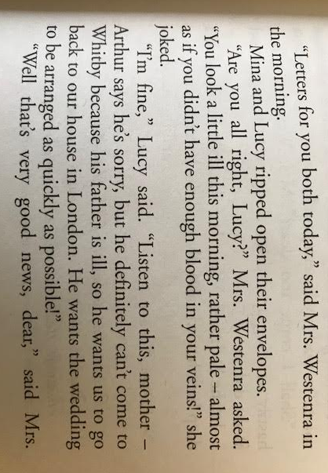
Circle the correct option

How did Mina and Lucy open their letters?
- Ripped
- Tore
- Quickly
- Roughly

How did Lucy look in the morning?
- Sick
- Pale
- Unwell
- Sleepy

Arthur can’t come to Whitby because:
- He is busy at work
- He is ill
- His father is poorly
- He wants to get married quickly.

Tuesday
Question Time
Ordering boxes act.
Mina leaves the kitchen with her letter

Mrs Westenra wants Mina to tell her what’s in the letter

Mina receives a letter

Mina discovers where Jonathan is

Mrs Westenra comments on Lucy’s health

Mina opens her letter

Question Time
Ordering boxes act.
Mina leaves the kitchen with her letter

Mrs Westenra wants Mina to tell her what’s in the letter

Mina receives a letter

Mina discovers where Jonathan is

Mrs Westenra comments on Lucy’s health

Mina opens her letter

