Tuesday 19th January / Li: to be able to write a setting a description (tricky)
I will be successful if:
- I can use full stops and capital letters
- I can use coordinating conjunctions (and, so, but)
- I can use subordinating conjunctions (because, while, when)
- I can use expanded noun phrases (2 adjectives before the noun)
- I can use verb
- I can use adverbs
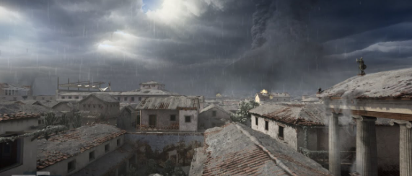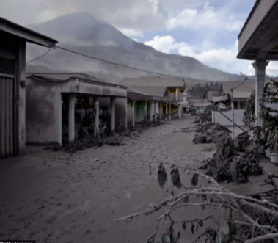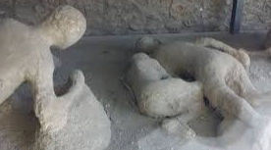
Write a setting description which describes how Pompeii looked after the eruption.
____________________________________________________________________________________________________________________________________________________________________________________________________________________________________________________________________________________________________________________________________________________________________________________________________________________________________________________________________________________________________________________________________________________________________________________________________________________________________________________________________________________________________________________________________________________________________________________________________________________________________________________________________________________________________________________________________________________________________________________________________________________________________________________________________________________________________________________________________________________________________________________________________________________________________________________________________________________________________________________________________________________

