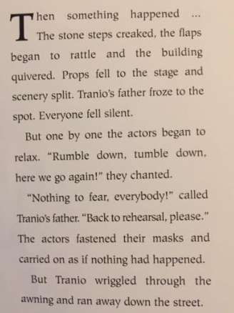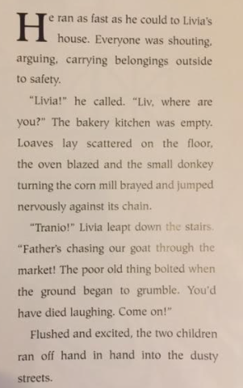

Complete the grid for the pages we have just read.
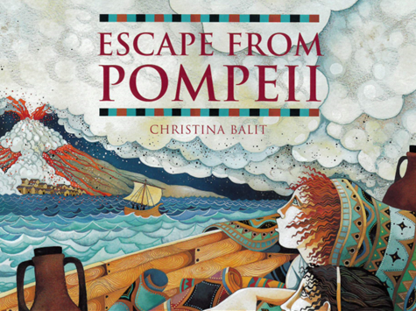 | Characters- who are the characters? | Settings – where does the story take place?
Story – what has happened?

