L.I:- To be able to simplify fractions.
I will be successful if I can..
- I can explain what simplify means.
- I can recall multiplication facts.
- I can draw images to represent the fraction.
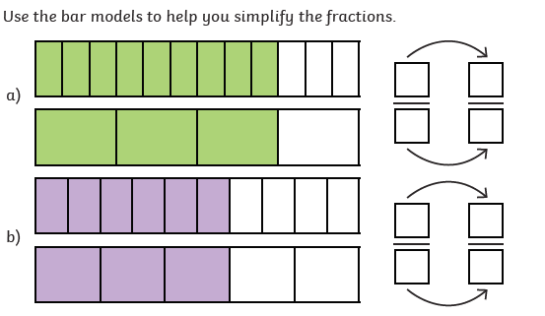
- Simplify $\frac{21}{42}$

- Simplify $\frac{18}{21}$

- Simplify $\frac{75}{100}$

- Which is the largest fraction $\frac{1}{5}$ or $\frac{15}{60}$
Explain how you know?

