**L.I:- To be able to solve problems involving percentages.**

I will be successful if..

* I can read and annotate the question.
* I can identify the skills required to answer the question – fraction, decimal or percentages.
* I can find 1 %, 10% 5%
* I can add, subtract and multiply.

**Try it**

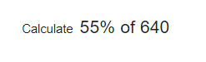

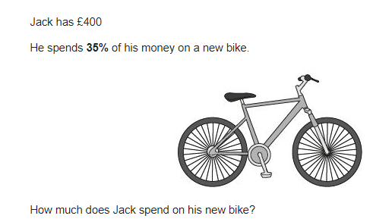

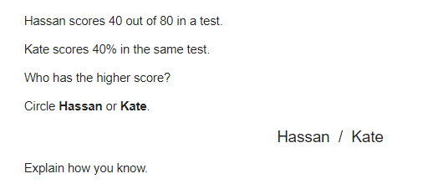

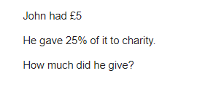

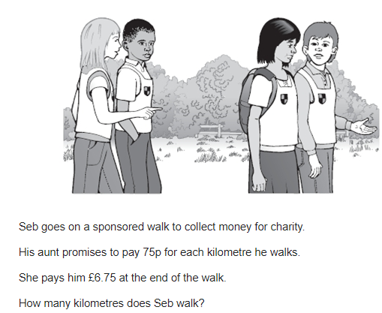**Apply it**

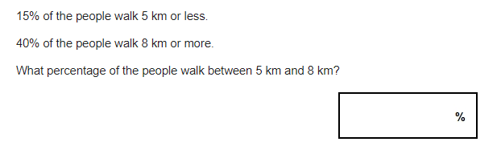

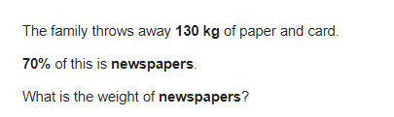

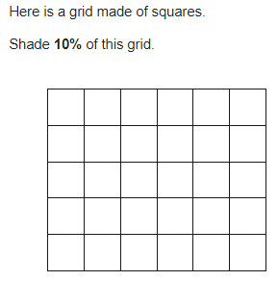

**Fly with it**

