20.1.2021- Maths
LI: To be able to identify quarters
I am able to understand that a quarter is splitting a whole into 4
I am able to write a quarter as a fraction.
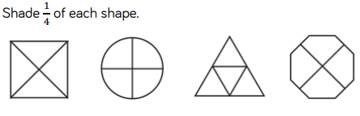

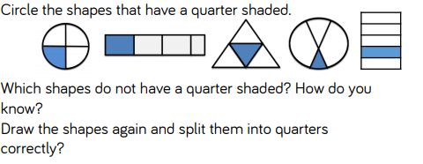

How do you write a quarter as a fraction?
____________________________________________

