Descriptive Writing
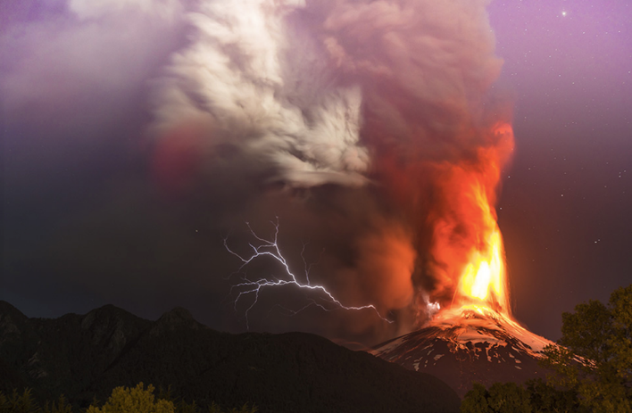
Write descriptive sentences which describe the image.
Pick your challenge level.

Bronze Level:
LI: to be able to construct descriptive sentences based on an image
I will be successful if:
- I can use expanded noun phrases (2 adjectives to describe a noun)
- I can use coordinating conjunctions (and, but, so)
- I can use subordinating conjunctions (as, while)

Silver Level:
LI: to be able to construct descriptive sentences based on an image
I will be successful if:
- I can use expanded noun phrases (2 adjectives to describe a noun)
- I can use verbs and adverbs
- I can use prepositions to describe place and position
- I can use coordinating conjunctions (and, but, so)
- I can use subordinating conjunctions (as, while)

Gold Level:
LI: to be able to construct descriptive sentences based on an image
I will be successful if:
- I can use fronted adverbials including a comma
- I can use expanded noun phrases (2 adjectives to describe a noun)
- I can use verbs and adverbs
- I can use prepositions to describe place and position
- I can use a range of coordinating conjunctions
- I can use a range of subordinating conjunctions

