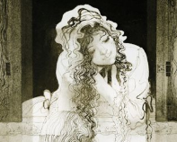

**My Question:**____________________________________

________________________________________________________________________________________________

**Bess’ Answer:** ____________________________________

________________________________________________________________________________________________________________________________________________________________________________________________

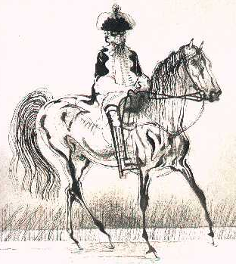

**My Question:**____________________________________

________________________________________________________________________________________________

**Highway Man’s Answer:** ________________________________________________

________________________________________________________________________________________________________________________________________________________________________________________________



**My Question:**____________________________________

________________________________________________________________________________________________

**Bess’ Answer:** ____________________________________

________________________________________________________________________________________________________________________________________________________________________________________________



**My Question:**____________________________________

________________________________________________________________________________________________

**Highway Man’s Answer:** ________________________________________________

________________________________________________________________________________________________________________________________________________________________________________________________