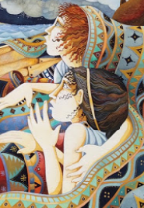
Prediction (2e)

 | My Prediction | Actual
Who are the characters?

What are they feeling?

Where are they?

What is happening?

