Draw it!
I stared in utter horror. With such care and patience I’d tried to create this being! Every part of him fitted his great size. I’d chosen his features in the hope they’d be beautiful. Beautiful!? His yellow skin barely covered the muscles and his veins beneath. His hair was shiny black and flowing. His teeth were pearly white.
But all was only the more horrible against his watery yellow eyes, his shrivelled skin, his straight black lips. An Egyptian mummy brought to life wouldn’t be as hideous as that Thing. I’d gazed on him when he was unfinished, and he was ugly then. But when those muscles and joints were able to move, he became a Thing of Nightmares.
Draw Frankenstein’s Monster using the description from the text above. Label using words and phrases.

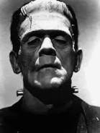
Character Analysis
Frankenstein’s Creature

Inside: personality/character
Outside: appearance

