LI: to be able to create a descriptive word bank based on an image
I will be successful if:
- I can discuss the image
- I can describe the image
- I identify the different types of words (nouns, verbs, adjectives, adverbs)

Nouns | Adjectives
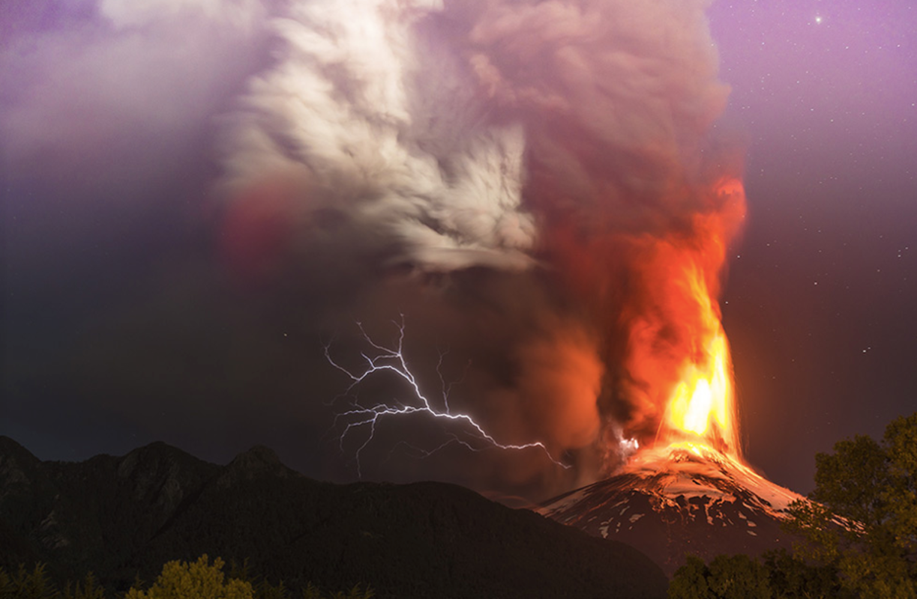
Verbs | Adverbs

