

**My Question:**____________________________________

________________________________________________________________________________________________

**Answer:** ________________________________________

________________________________________________________________________________________________________________________________________________________________________________________________

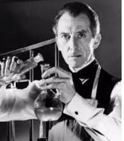

**My Question:**____________________________________

________________________________________________________________________________________________

**Answer:** ________________________________________

________________________________________________________________________________________________________________________________________________________________________________________________



**My Question:**____________________________________

________________________________________________________________________________________________

**Answer:** ________________________________________

________________________________________________________________________________________________________________________________________________________________________________________________



**My Question:**____________________________________

________________________________________________________________________________________________

**Answer:** ________________________________________

________________________________________________________________________________________________________________________________________________________________________________________________