Wednesday 13th January 2020
Content Domain: 1b identify key aspects of non-fiction texts, such as titles and information
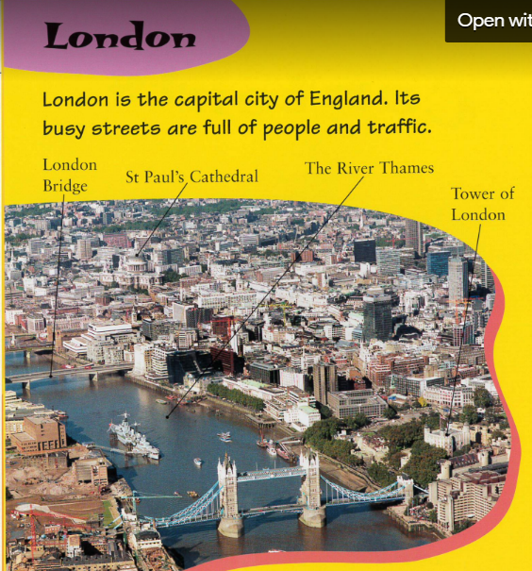
Read the words in the text box and work out where they need writing as labels, - remember to use your phonics to soundtalk the green words and blend the words.
London bridge Tower of London
St Paul’s Cathedral The River Thames

