Wednesday 13th January 2020
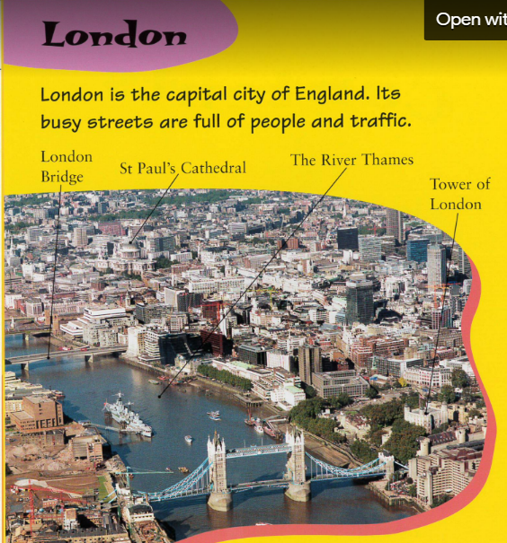
2b- Retrieve and record key information/ key details from fiction/ non-fiction.

London bridge Tower of London
St Paul’s cathedral The River Thames
Challenge:
What are the busy streets full of?
_____________________________________________________________
What country is London the capital city of?
______________________________________________________________

