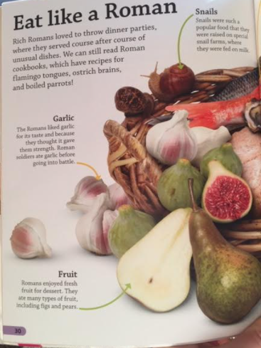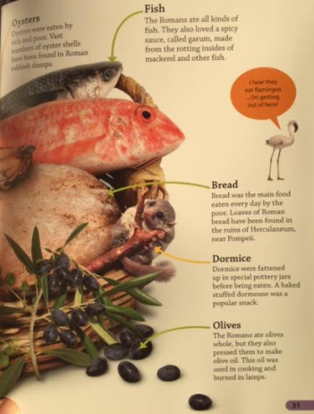

**Wednesday 27th January**

**Eat like a Roman**

Label the diagram

