Wednesday 27th January
Morning Maths

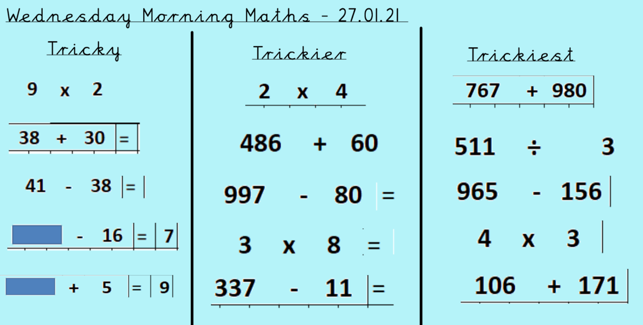

Now have a go at the lesson on Mymaths for 4 times tables.
The lessons has been set for you as an activity.
Log in to mymaths:
www.mymaths.co.uk
stjames8 square204 Use your own log in after that to log into your personal account. The task has been set for you on there.

