Wednesday 3rd February
LI: to be able to use and identify subordinate conjunctions
I will be successful if:
- I can recall subordinate conjunctions
- I can identify subordinate conjunctions in a sentence
- I can use subordinate conjunctions

What does I SAW A WABUB stand for?
I | S | A | W | A | W | A | B | U | B

Identify the subordinate conjunction in each sentence.
Lucas rowed until Pompeii was a small speck on the horizon.
Growling loudly, Lucas’ stomach rumbled because he had not eaten all day.
The people of Pompeii rushed to find shelter as Vesuvius erupted.
Lucas opened his mouth when suddenly he started to choke.
Everything went dark since the ash had covered the sun.

Choose the best subordinate conjunction to complete the sentence (because, as, since, when, until)
Lucas fished _____________ the sky went dark.
Vesuvius rumbled ____________ rocks tumbled down.
The boat rocked _____________ the waves were getting bigger.
Lucas had worked for the captain ____________ he was young.
People started to panic ____________ Vesuvius began to erupt.

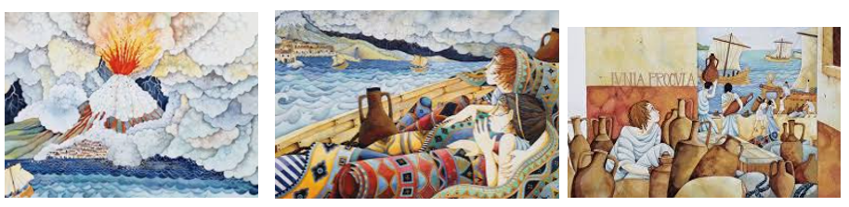
Sentence Creator- write your own sentences using – because, as, since, until
_________________________________________________________________________________________________________________________________________________________________________________________________________________________________________________________________________________________________________________________________________________________________________________________________________________________________________________________________________________________________________________________________________________________________________________________________________________________________________________________________________________________________________________________________________________________________________________________________________________________________________________________________________________________________________________________________________________________________________________________________________________________________________________________________________________________________________________________________________________________________________________________________________________________________________________________________________________________________________________________________________________________________________________________________________________________________________________________________________________________________________________________________________________________________________________________________________________________________________________________

