Wednesday 27th January / Li: to be able to write an ending of a Rags to Riches story (tricky)
I will be successful if:
- I can use full stops and capital letters
- I can use coordinating conjunctions (and, so, but)
- I can use subordinating conjunctions (because, while, when)
- I can use expanded noun phrases (2 adjectives before the noun)
- I can use verb
- I can use adverbs
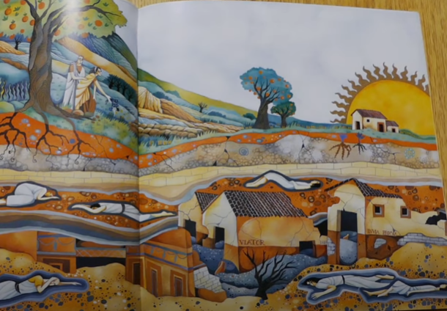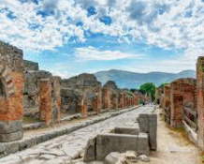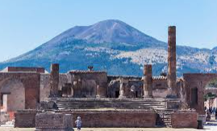
Write the ending paragraph of our story ‘The Hero of Pompeii’
Action Points to include:
- Describe what Lucas see from the boat
- Describe how Lucas feels
- Explain what happens to Lucas
__________________________________________________________________________________________________________________________________________________________________________________________________________________________________________________________________________________________________________________________________________________________________________________________________________________________________________________________________________________________________________________________________________________________________________________________________________________________________________________________________________________________________________________________________________________________________________________________________________________________________________________________________________________________________________________________________________________________________________________________________________________________________________________________________________________________________________________________________________________________________________________________________________________

