Wednesday 27th January
Instructions for division as the inverse of Multiplication
Start with the division question and work out the answer.
195 ÷ 3 =
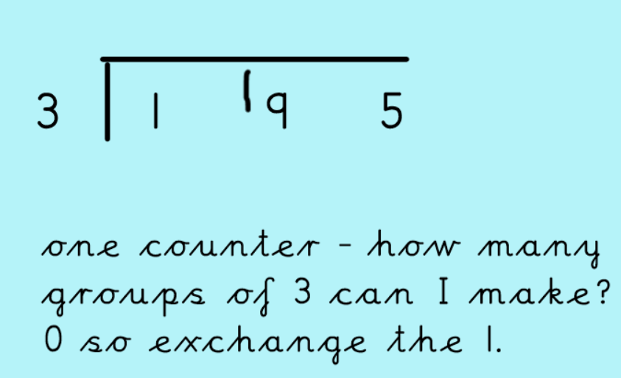
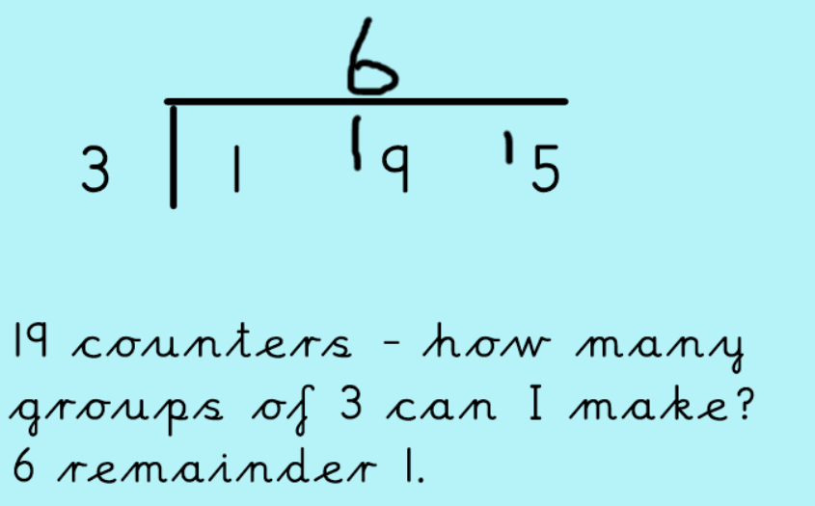
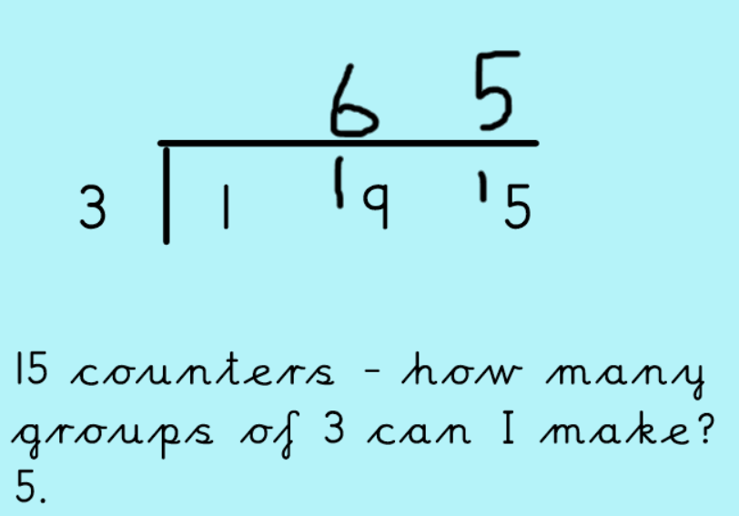
Now use multiplication as the inverse.
65 x 3 =
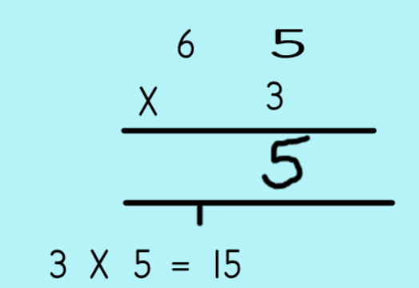
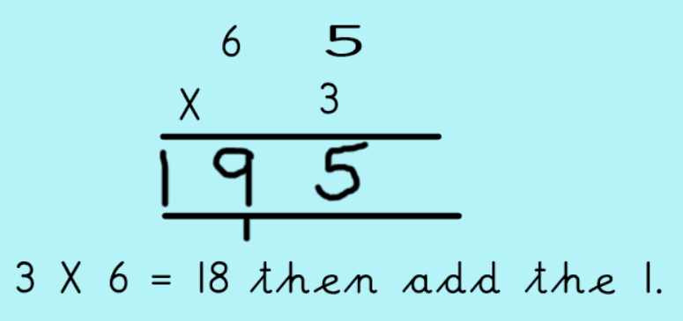

Have a go at the division and multiplication activity. If you get stuck, watch the loom video on the website.

