Wednesday 20th January
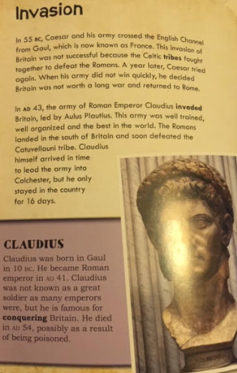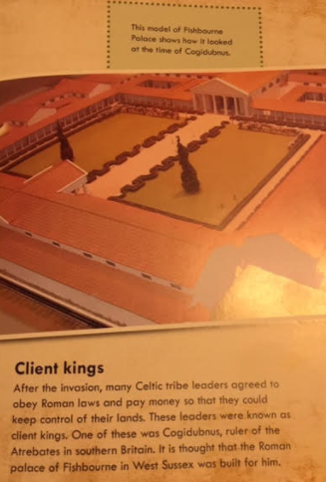

Read the text above and answer the questions
Look in the first 2 paragraphs for these answers.
- What year did Caesar invade Britain?
- Why did Caser’s first invasion fail?
- What was the reason Caesar’s second invasion didn’t last long?
- Which emperor invaded Britain in AD43?
- Why was the Roman army able to defeat the Britain’s in AD43? Find and copy 2 reasons.
- How do we know that Claudius didn’t stay long in Britain? Find and copy a phrase.
Read the paragraph ‘Client Kings’
- What was a client king?
- Name one client king.
- Where did he live?

