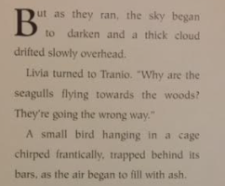

Read the text and write down a consequence for each action.
e.g. if they go and hide, what could happen as a result of that?

Go to the forum
Run to harbour
Go and hide
Run back home
What should Tranio and Livia do?

