L.I:- To be able to recognise and find the angles within a quadrilateral.
I will be successful if..
- I can name 2d shapes.
- I can recognise the value of angles within a quadrilateral.
- I can subtract mentally.
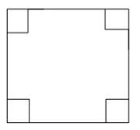

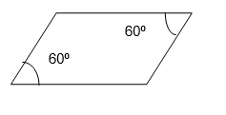
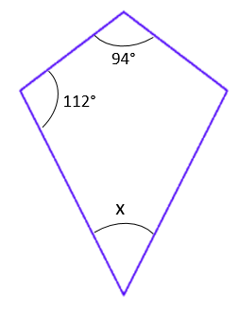

Apply it!
