- To explain how waves form.
- To describe the differences between constructive and destructive waves.
- To explain how longshore drift works.
What is a Coast?

Waves play a key role in shaping the coast, but how do waves form?
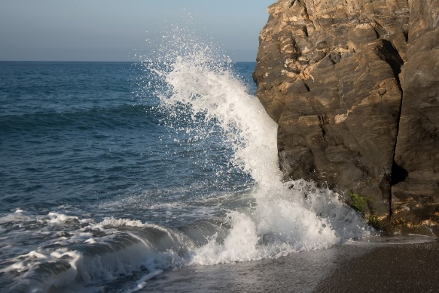
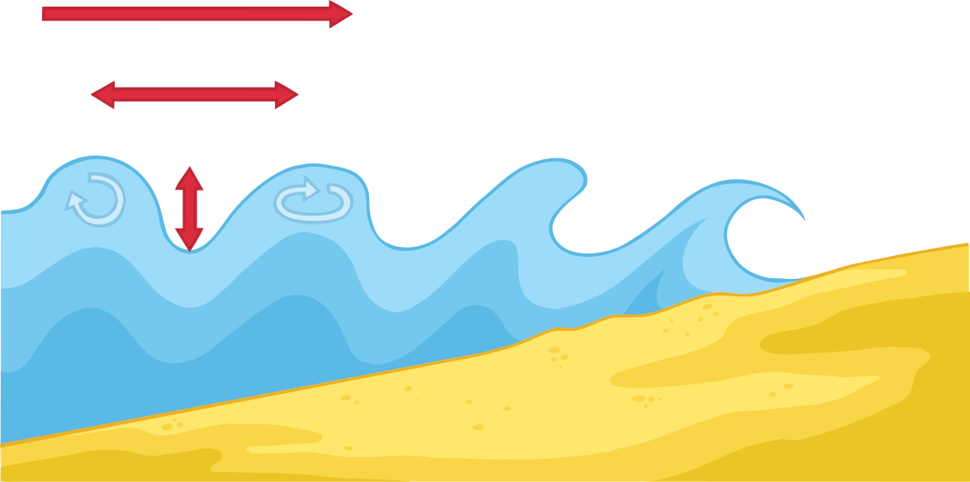

What are the two types of wave called, and how are they different?
1.

2.

What is Longshore Drift?
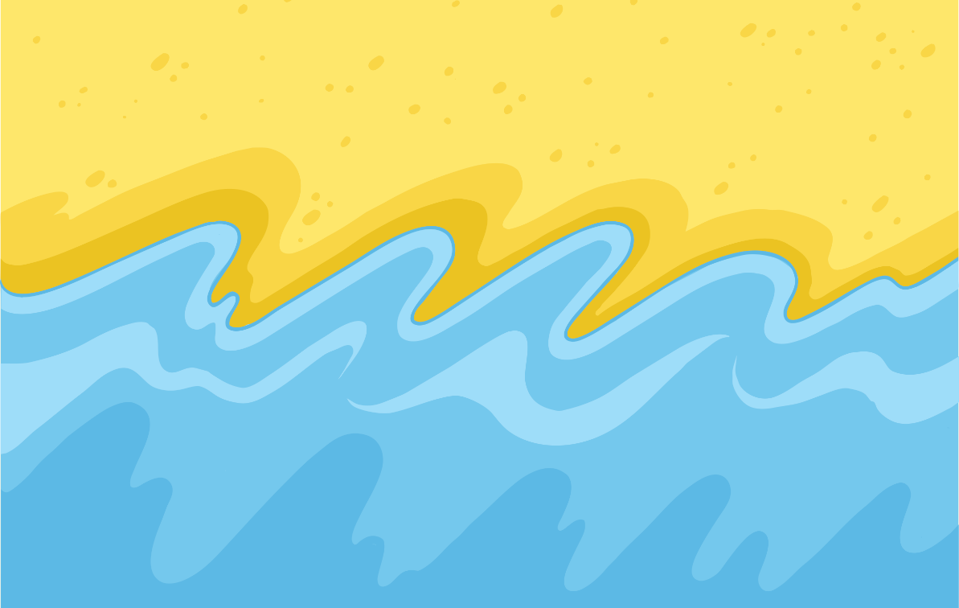

What is done to try to prevent longshore drift, and why are measures taken to try to prevent it from happening?

