R.E. – Week 3
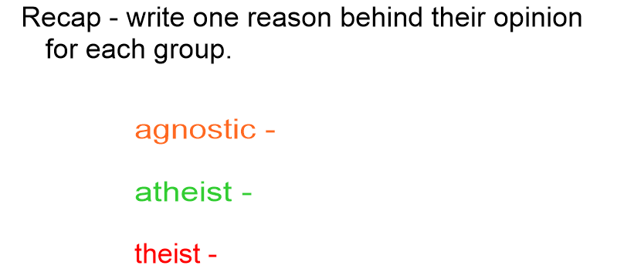

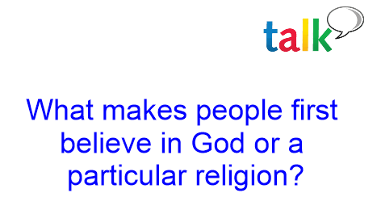

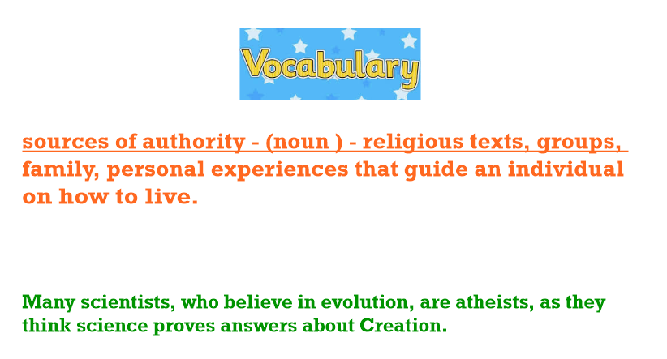

In our last lesson, we discussed how God is often represented in popular culture.

Jesus is known by many names and metaphors.
Which can you remember?

L.I. To express reasons why people believe or do not believe in God.
I can explain and discuss the term: sources of authority.
I can suggest reasons why people may or may not believe in God.
I can identify metaphors used about God, and how people of faith might respond to them.
I can express my own views.

On the next sheet, you will see a number of metaphors used to describe God in the Bible.
How might Christians feel about these choices of metaphor?
Why would they be important characteristics that strengthen their faith?

We would like you to respond to the metaphors – how do they make you feel about God and faith?

Are there other metaphors that you know about, either in the Bible or other holy texts? We would love for you to share any ideas you have from other faiths!

Quote. | What this might mean to Christians.
