Wellbeing – Physically active ideas for Enrichment afternoons
Go for a walk as a family and see if you can spot the following:  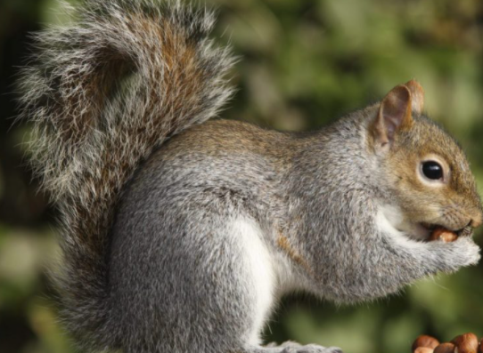  - 3 different types of bird  - 3 different types of tree  - 3 different types of flowers  - A squirrel  Take photos and share them on dojo. | Cycle safely round your local area  Remember to wear a helmet and to stay safe on the roads or paths.  Get your adult to take a photo of you on your bike to share on dojo. | Try some of the “This is PE” activities outside in your garden.  The activities can be found on our school website in the home learning tab.  Remember to take photos for dojo!  https://academystjames.com/pe-physical-activity-at-home/
Create an exercise circuit in your garden and have a go with your family.  You could include:  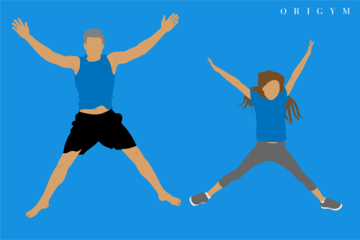  - star jumps  - jogging on the spot  - squats  - knee lifts  - jumping side to side  Don’t forget those photos for dojo! | Find a piece of rope or a skipping rope and try different types of skipping.  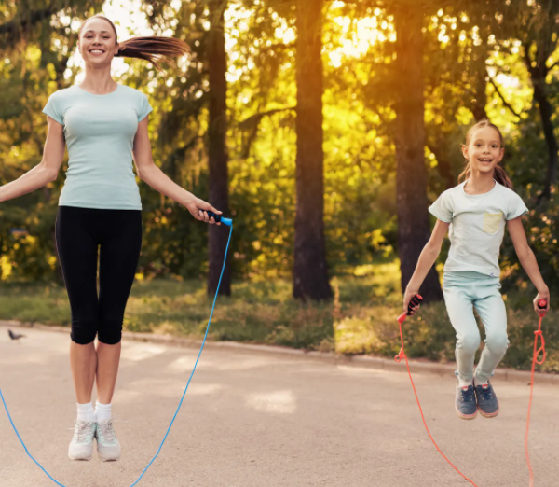  - skipping backwards  - crossing your arms over in front of you  - skipping together with someone in your family (both facing each other, with one rope) | Go for a jog as a family.  You could start the couch to 5k app.  It starts with walking and a few seconds of jogging.  You will be amazed how well you progress over the weeks.
Take your phone/ tablet outside and do some photography.  Take close up pictures and pictures from different angles of interesting things in your house/ garden.  Make a pic collage of the photos and send us them on dojo. | cook / make a healthy snack for the family.  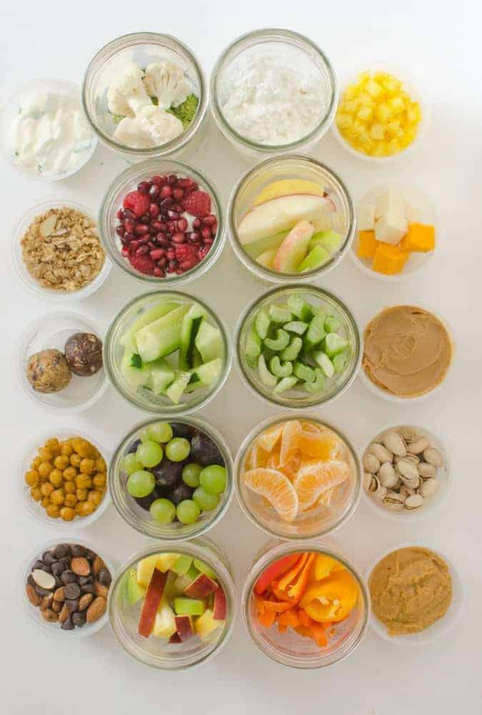  Take photos and add them to dojo! | We could like to see pictures of your activities and of you having fun together as a family.  Family time is so important and so is physical activity. Being active makes you feel better and happier!

