

**4) Why would mum not be friends with the old lady?**

**3) Why would this make mum sad?**

**2) Do you agree that the narrator shouldn’t think about Aunty Selma? Why?**

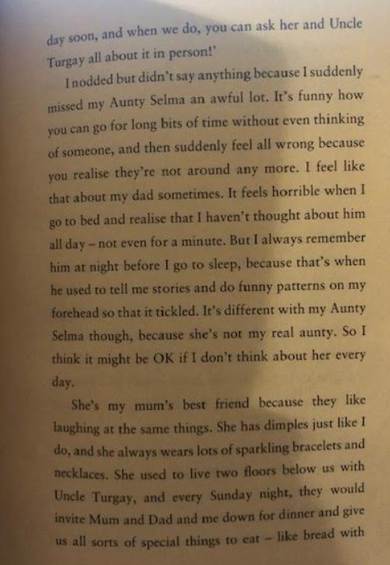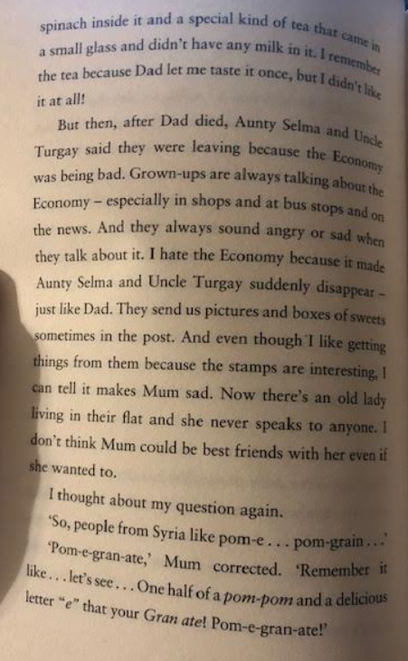

**1) Why do you think the narrator feels so horrible about not thinking about their dad all day?**

Wring It Out