English on Friday –

Look back at the story you have written on Tuesday and Thursday. Today you have to check it and make sure you have everything in the right place. Use this check list and fix your story where you need to.
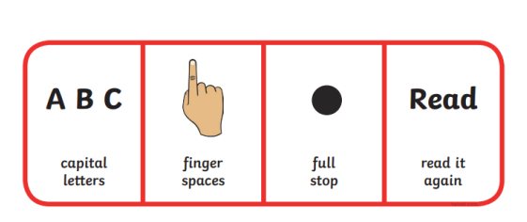
When you have made sure your story is perfectly written you need to publish it by making it into a book.

You can use the template attached or find another way to tell us your new story about The Great Fire of London.
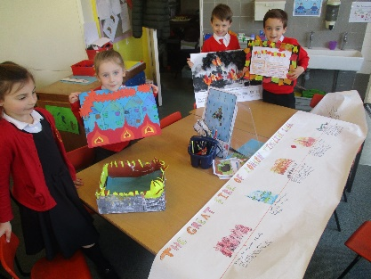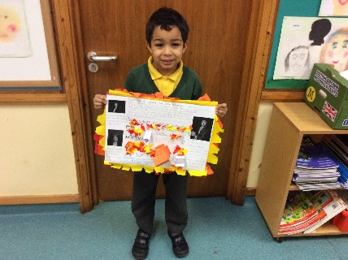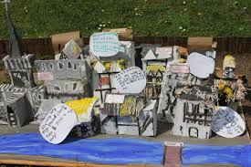

_______________________________________________________________________________________________________________________________________________________________________________________________________

3
2
4
1
________________________________________
_______________________________________________________________________________________________________________________________________________________________________________________________________
_______________________________________________________________________________________________________________________________________________________________________________________________________

