Monday 25th January 2021
LI: To write a sequence of sentences using full stops and capital letters.
I can say the sentence I want to write.
I can use a capital letter at the start of a sentence.
I can use a full stop at the end of my sentences.
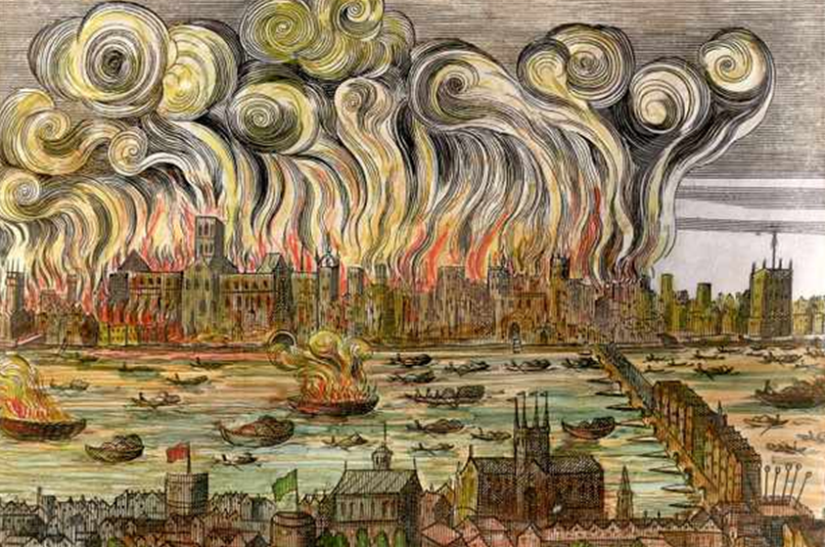

If you were Vlad the flea and you were travelling down Pudding Lane when the Great Fire of London was happening…
What would you see? | What would you hear? | What would you smell?
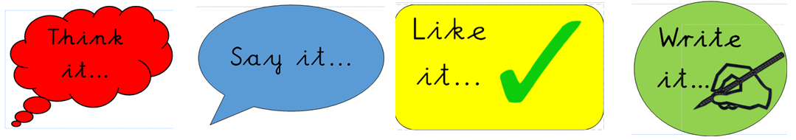

Write one sentence for each box above to make a sequence of three sentences.
____________________________________________________________________________________________________________________________________________________________________________________________________________________________________________________________________________________________________________________________________________________________________________________________________________________________________________________________________________________________________________________________________________________________________________________________________________________________________________________________________________________________________________________________________________________________________________________________________________________________________________________________________________________________________________________________________________________________________________________________________________________________________________________________
____________________________________________________________________________________________________________________________________________________________________________________________________________________________________________________________________________________________________________________________________________________________________________________________________________________________________________________________________________________________________________________________________________________________________________________________________________________________________________________________________________________________________________________________________________________________________________________________________________________________________________________________________________________________________________________________________________________________________________________________________________________________________________________________
__________________________________________________________________________________________________________________________________________________________________________________________________________________________________________________________________________________________________________________

