Wednesday 13th January 2020
LI: To write a character description using adjectives.
I can talk about the characters in the story.
I can use adjectives for description.
I can change the model to my own character.

Change the red words in the giant’s description model using your flea template from yesterday to create a new character description for Vlad.

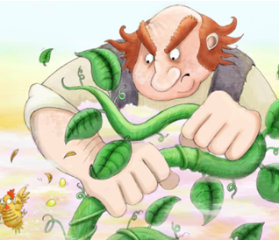

He was huge with great big eyes and a grumpy face.

