Maths this week will focus on odd and even numbers. We have included some notes to help the adults teach their children about odd and even numbers at home if they can not log on to live lessons at 11:15am on Tuesday to Friday
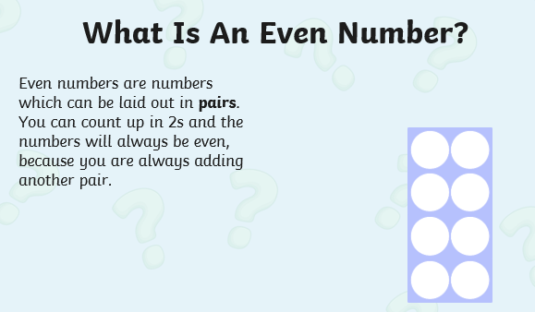
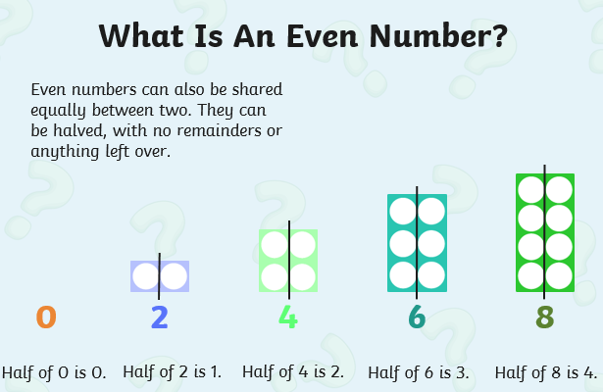
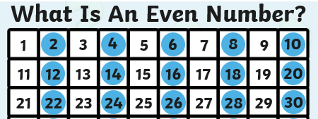

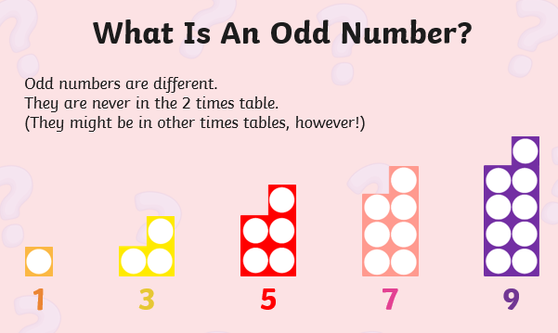
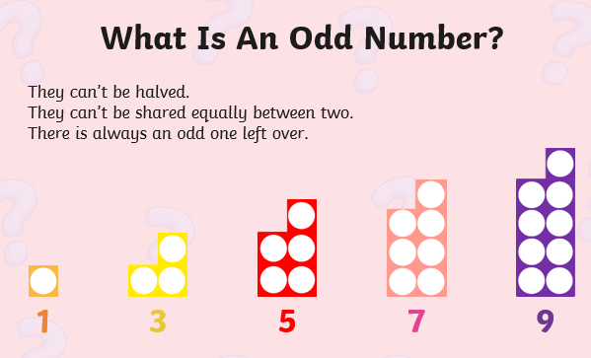
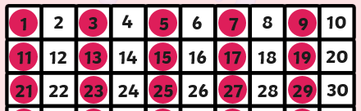

Maths lesson 1 – Tuesday
Cut out or create two sets of numicon to help you in our maths lessons this week – keep them safe we will need them most days.
Sort the numicon pictures into odd and even numbers.
