29.01.2021
LI: To investigate addition with even numbers.
I can identify odd numbers to 20
I can subtract a single digit to a two-digit number within 20
I can identify a pattern

Investigate what happens when you subtract an odd numbers from another odd number.
Is the answer odd or even? _______________________________________________________
Is the answer always an odd number or even number? ________________
Use the number grid below to help you.
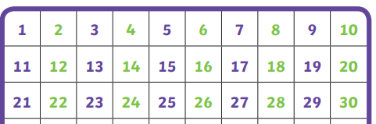

Here are a few subtraction number sentences to get you started but you will need to create some of your own to make sure your answers to the questions above are correct.

9 - 7 = 13 - 3 =

11 -3 = 15 - 1 =
Write your own number sentences on this squared paper – remember to only put one number in each square.
